Assignment 4
A turboshaft engine works on n=18000rpm, 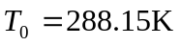, M=0, H=0(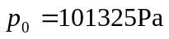).
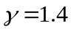，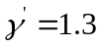，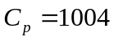，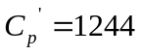
Shaft power =9000kW, massflow 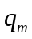=20kg/s,
intake total pressure recovery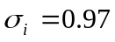,
compressor 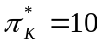 and 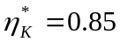,
combustion chamber 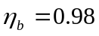 and 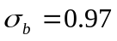 and 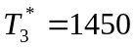,
turbine 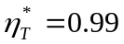,
nozzle 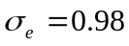.

Find：the total temperature, total pressure in every section and sfc (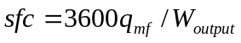)（kg/h.kJ）
Hint：use 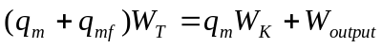 and 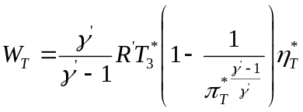 to find 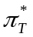 where 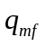 is fuel massflow.

Possible problem：